   
Customer Profile

Manufacturing Profits at a Semiconductor Fabrication Plant

How Splunk Software Applies Real-Time Analytics to the Manufacturing Floor

(or) How Splunk Software Applies Real-Time Analytics to the Internet of Things

A quiet evolution has been occurring in the world of global electronics manufacturing over this past decade: the electronics revolution is meeting the internet revolution is meeting machine intelligence, with results that we once only heard about in science fiction. On factory floors, automated decisions direct material carriers, strategically driving and rerouting high-cost components through dozens of processes, avoiding bottlenecks and maximizing yield. You could say that these intelligent devices are, in a sense, creating others like themselves, but that’s another story and a different topic.

***This*** story is about how one Splunk customer, a 10B APAC electronics manufacturer, found that Splunk software could bring the power of big data analytics to semiconductor fabrication, reducing downtime, avoiding defects and increasing yield. The pressure to continually innovate and streamline was endemic to the industry, yet, with each significant ‘improvement’ there was a substantial risk of expensive, unintended consequences. Throughout the plant, operating expenses were increasing, due to inefficiencies and increased defect rate. Root causes of downtime and defects were impossible to detect quickly, magnifying problems and losses exponentially as issues remained unsolved.

The customer determined that, to get the visibility they needed, they needed four major products, each specializing in a specific capability: a Complex Event Processer (CEP) System, a Big Data platform, a statistical management platform, and industrial visualization software. A team of twenty specialists was in the process of attempting to weave these systems together for a working prototype; they estimated it would take a full year. Then, one of the Operations Managers happened to attend a weekly Splunk meeting in another part of the semiconductor plant where Splunk software had been rolled out to meet security requirements. Further research revealed that, not only could Splunk software be applied to the machine data coming in from the manufacturing floor -- Splunk could handle all 4 of the major functions required in the prototype. A 4-person team of Splunk experts put together a working Proof-of-Concept in 3 months, which they presented on a Friday afternoon. When the decision makers saw what the Splunk platform could do, and the fact that it would have an immediate, positive, provable impact on the yield (and hence profits), they wrote the Purchase Order that Monday and began to immediately deploy Splunk software. Splunk software had the capabilities of all 4 systems, in one comprehensive, easy–to-tailor platform. Applying the all-in-one solution of Splunk software replaced chaos with synergy: optimizing yield, stopping bottlenecks, and preventing downtime in the ever-evolving world of semiconductor fabrication, saving millions of dollars in the --process.

With Splunk the customer has:

* **Complex Event Processing capability near real time** due to Splunk software’s ability to correlate data, create meaningful searches, and spot anomalies and opportunities on the fly
* **Big Data platform** real-time data collection, storing and querying
* **Statistical management platform** apps, algorithms, and access to tools and equations that provide answers
* **Visualization** that enhances pattern-learning and insights for the business as well as operational staff

Splunk is far cheaper to implement and own than the competition and has a significant positive impact on yield and profits.

**Splunk Decodes Complex Manufacturing Process**

|  |  |  |
| --- | --- | --- |
| **Splunk Value** | **How Value Is Measured** | **Business Impact** |
| All –in one, integrated platform | * Fast time to value, no integration nightmares, much smaller staff * Full Stack; no need to invest in multiple tools | * Staff needed for deployment of Splunk platform was 1/5 staff needed for competing set of systems * The cost of Splunk is far cheaper than the price of the multiple systems required to perform similar functions |
| Near Real-Time Complex Event Processing (CEP) | * Fast & Simple deployments * Increased Yield * Easy rule creation and to respond to new information | * Increased yield means increased profits, measured in millions of dollars per year |
| Big Data Platform | * Efficiency and simplicity * Storing and summarizing vast amounts of data | * Quick access to data as needed |
| Advanced Analytics | * Quick insights * Correlations | * Decreased Operating expenses due to found efficiencies and fewer defects * Identify those process enhancements that increase yield, quickly enough to profit the most from them |
| Industrial Visualization: | * Prioritize data collection and analysis * Baseline, correlate, verify, optimize | * Identify NORM patterns, find innovations * Increase uptime |
| Significance Testing | * Verify Hypothesis | * Root cause of yield drop and focus on significant factors * Increase uptime |
| Predictive Modeling | * Quantify impact of optimal ranges for identified factors | * Quickly adjust processes to maximize yield, maximizing profits as well |

Wafer Madness

What exactly are wafers, and how do they become chips? Wafers are (usually) small, thin, shiny, silicon disks, created from highly specialized processes. The disks, which resemble a DVD, are about 1” to 18 “ in diameter. Wafers are the canvas on which compter chips are drawn, etched, and chemically processed. The larger the wafer, the more chips can be created at one time.

These are examples of processes that wafers undergo in the journey from wafer to chips:

* Cleaning
* Texturing
* Etching
* Ion Implantation
* Doping
* Deposition of Materials
* Photolithographic patterning
* Dicing

At this customer’s plant, a wafer might go through dozens of steps on its path to becoming a series of chips. Several processes are so complex that precision is measured in terms of atoms, yet length of etched pathways are measured in kilometers. The processes can take weeks. Automated ‘carriers’ move the wafers from station to station. It is critical that certain processes happen in a set order, but it is not important that all processes happen in a set order. Intelligent decision algorithms are enacted in real time that change the order of processing depending on bottlenecks, downed machines, and related factors. All of this machine data was critical and important, but it it took weeks to get the logs and longer to get meaning from them.

.A run of wafers can produce chips worth millions of dollars, headed for automobiles, smart phones, televisions, home appliances, thermostats, medical devices, and similar items. This Splunk customer created chips for their own items and they also contracted to make chips for client and partner companies. Downtime not only decreased profits, but it also caused delays in the finely tuned processes of these client customers as well. And mistakes in processes or the order of processes were also expensive: wasted material and opportunity costs of the ill-fated wafers, a total loss. System downtime and lowered productivity decreased yield, costing the customer millions of dollars.

What can go wrong in the process of creating wafers? Here are just a few examples:

* Processes can get stuck in an infinite loop, repeating the same steps or series of steps
* A defect can occur on a line or in a process
* A critical process step can be stopped or broken
* A carrier can be stopped, backing up traffic
* A set of wafers can be somehow flawed

Each of these processes can significantly affect yield, and that significantly affects profits. It was difficult for operations management to keep up with automated processes, let alone optimize them. Yet, competion was fierce, demand was high. With each significant ‘improvement’ there was a substantial risk of unintended consequences.

Enter Splunk

In this use case, Splunk software is actually working with software that controls the movement of literal, rather than virtual, objects, changing the path taken by items on the manufacturing floor. For example, after the team used Splunk software to understand processes and error conditions with more insight, they programmed Splunk alerts to interact with manufacturing software in ways that caught problems very early, paying for the Splunk implementation soon after it was deployed. Figure 1 shows what happens when an issue occurs between the third and fourth process step. (Note: In the illustration, and those that follow, hundreds of steps are condensed into 8 in order to make complex scenarios understandable. In actuality, Splunk software has been used to tailor over 200 rules and corrective actions for hundreds of possible scenarios.) Splunk software makes it possible to tune manufacturing systems to create immediate corrective actions and rules, causing issues to be fixed in minutes rather than hours, or hours rather than weeks, depending on the complexity.

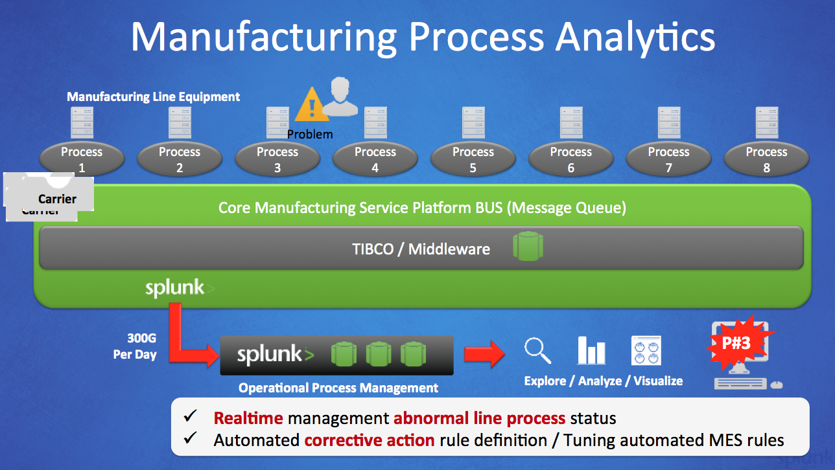

Figure 1 An Error Condition triggers corrective action

The customer designed its manufacturing software to respond to conditions, backups, and defects in the most efficient way possible, so that, when feasible, a wafer might undergo Process 4 prior to undergoing Station 2 for example. And if there is a defect after a process, a wafer might repeat a prior process or the same process, until the defect is fixed. But, as we pointed out before, things can go wrong. A wafer can get into an ‘infinite loop’ and cause bottlenecks or other issues on the floor. Figure 2 illustrates “normal” and alternative paths, including some paths that are indicative of defects or problems in the manufacturing process.

Before Splunk software, it was nearly impossible to gain insight into which alternative paths were associated with later defect issues, and which were not. But when the customer applied Splunk to the problem, it was finally possible to see the big picture and find opportunities to tune the processes even further.

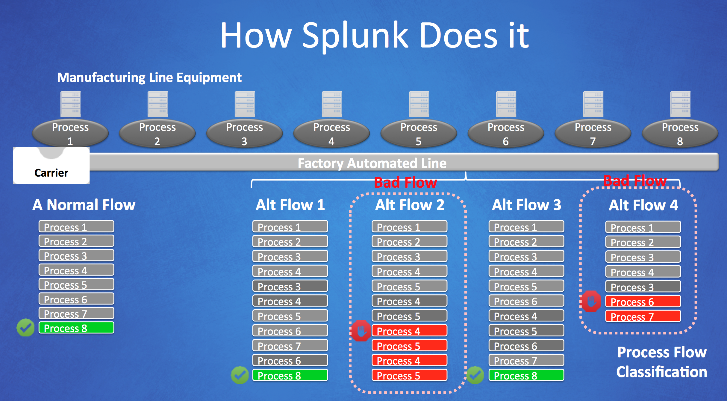

Figure 2 Alternative Flows

Figure 3 shows an example of how Splunk search was used to discover patterns.

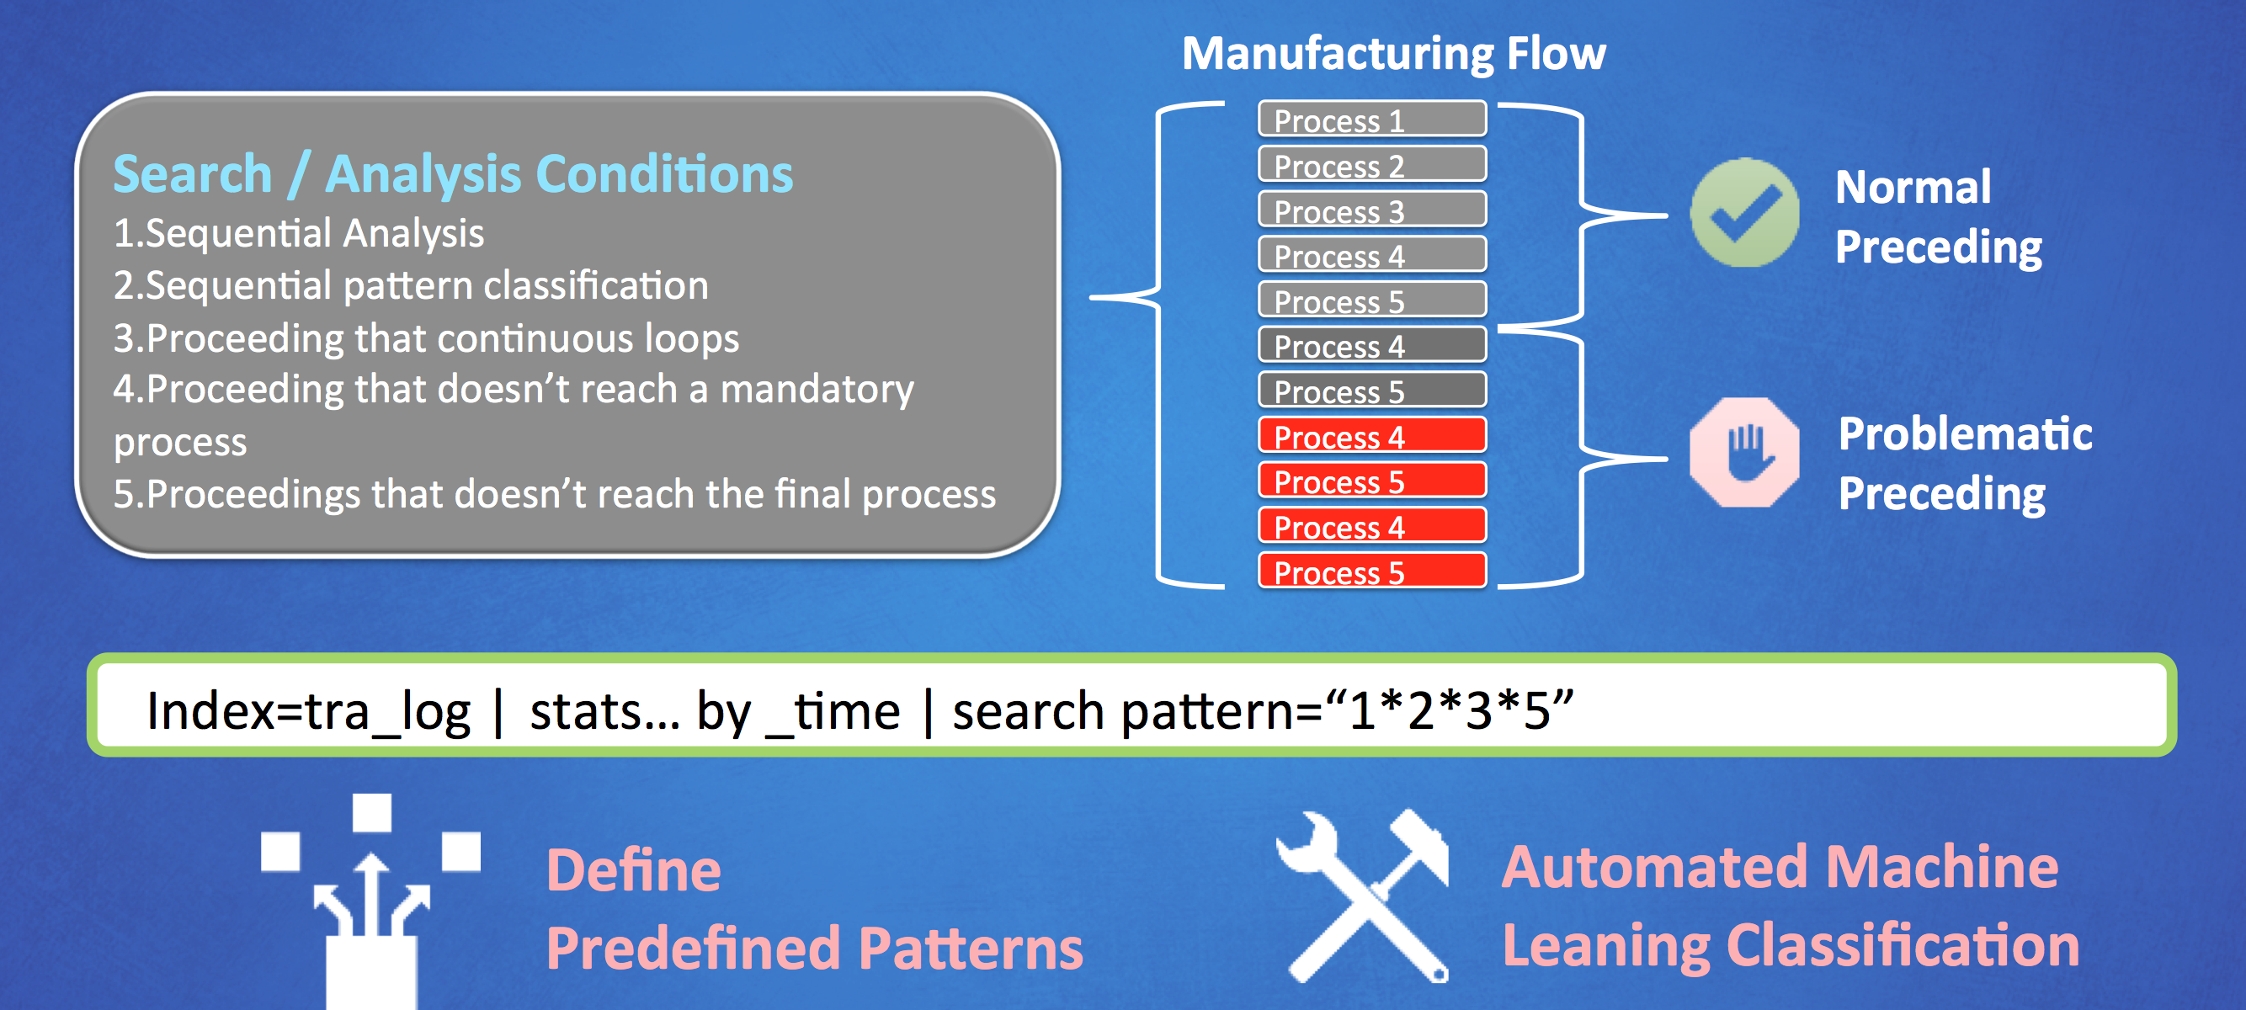

Figure 3 Index Search Statement

CREATIVE SERVICES: Please Replace the Gray Oval Box as Follows:

Examples of Splunk Software Insights:

* Sequential Analysis
* Sequential Pattern Classification

Examples of Conditions That Splunk Software Finds:

* Proceedings that Continuously Loop
* Proceedings that stop before it reaches a mandatory step
* Proceedings that never reach the final process

Let the Chips Fall Where It Pays

The semiconductor business is built on continual miniaturization and innovation. But before you innovate, you need to know what you have. This Splunk customer realized quickly that Splunk software could help it define and discover the following “silicon-gold” to increase its yield and profits:

* Known Good: The baseline, what they knew worked
* Known Bad: Users predefining search patterns manually—they had to know what they were looking for before they could find it and this was time consuming
* Unknown Bad: They needed to find these and write alerts to prevent them in the future
* Unknown Good: To find this, apply statistical model for process optimizations

These are self-explanatory, but what do you mean about Splunk software has led the customer to find “unknown good”? Well, because of conditions on the floor, at times the order of processes differed from the “known good.” Statistics predict that, if some of these deviations were less profitable, others might be more profitable. With Splunk software, analysts were able to build searches and dashboards to discover “unknown good” and optimize profits in novel, unexpected ways by rerouting the maximum number of wafers through the paths that would maximize profits via significant productivity gains. Splunk software made it possible to follow the clues to higher profits through a maze of dat; because now the path was clear.

<Irina For your amusment—and-- pick the one you most like!)

With Splunk, the Circuit was Complete

With Splunk, the Wafer Success was Clear ☺

Atomic Process: Astronomic Profits

Precision Decisions

Another wafer the customer to make profits (sorry!) ☺

The Circuitious Route Toward Splunk Inc

In this use case, we explored how Splunk software enables operational intelligence and business analytics on the manufacturing floor, applying Splunk analytics to the emerging world of internet of things. This customer plans to increase their use of Splunk 10 times over just in the current fabrication facility because they know that the insights gained will pay for themselves 10 times over.

This use case demonstrated:

**• Elimination of data silos.** Because Splunk software indexes all kinds of data, the customer can finally see how complex manufacturing processes intersect, allowing them to find synergies and patterns that were previously invisible.

**• Correlations drive analytics**. Because Splunk correlates different types of data, the customer has discovered ways to maximize yield and minimize factory downtime.

**• Flexible analytics powered by a read-time schema**. Because Splunk collects data in full fidelity without filtering, the customer can quickly adapt when the format that a new machine or process outputs changes unexpectedly. The customer does not need to spend months getting disparate systems to make sense. Splunk software has built in synergy.